**Assignment 1**

**1.What is the difference between data analysis and machine learning?**

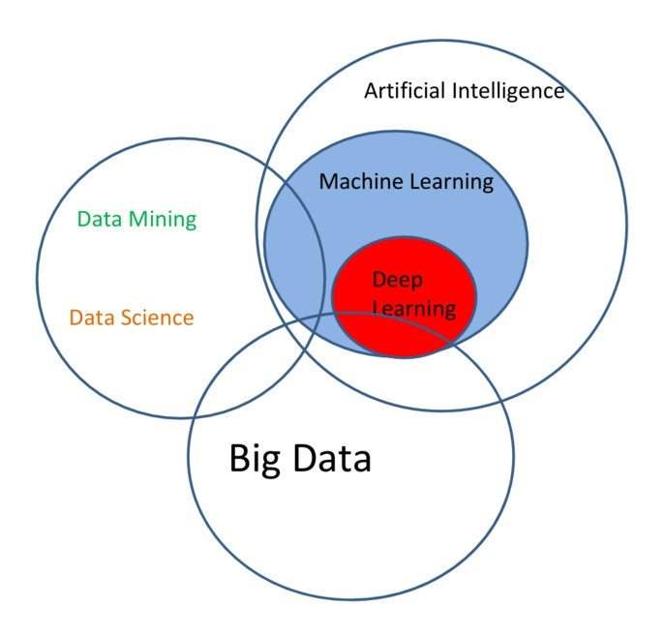

From the diagram it is clear that Machine learning and Data science/Data analytics are not mutually exclusive of each other.

Data Analysis

It is the process of inspecting, cleansing, transforming, and modelling data for discovering useful information.

Data analysis is mostly done manually by a data analyst.

Machine Learning

It is an application of AI that provides systems the ability to automatically learn and improve from experience without being explicitly programmed.

Machine learning focuses on the development of computer programs that can access data and use it to learn for themselves.

**2.What is big data?**

It is a term used to describe large volumes of data that can be both structured and unstructured data.

Big data can be analyzed for insights that improve decisions and give confidence for making strategic business moves.

**3.What are the four main things we should know before studying data analysis?**

a. You have to like working with numbers.

b. You have to know how to code, but you don’t have to know computer science.

c. You have to have good communication skills.

d. Much of what you’ll do won’t be at the top of the job description.

**4.Most common characteristics used in descriptive statistics?**

-Measures of central tendency

-Measures of variability(spread)

**5.What is quantitative data and qualitative data?**

Quantitative data are about numeric variables (eg : how many, how much, how often etc).

Qualitative data are measures of types and may be represented by a name, symbol or a number code (eg: what type, what category etc).